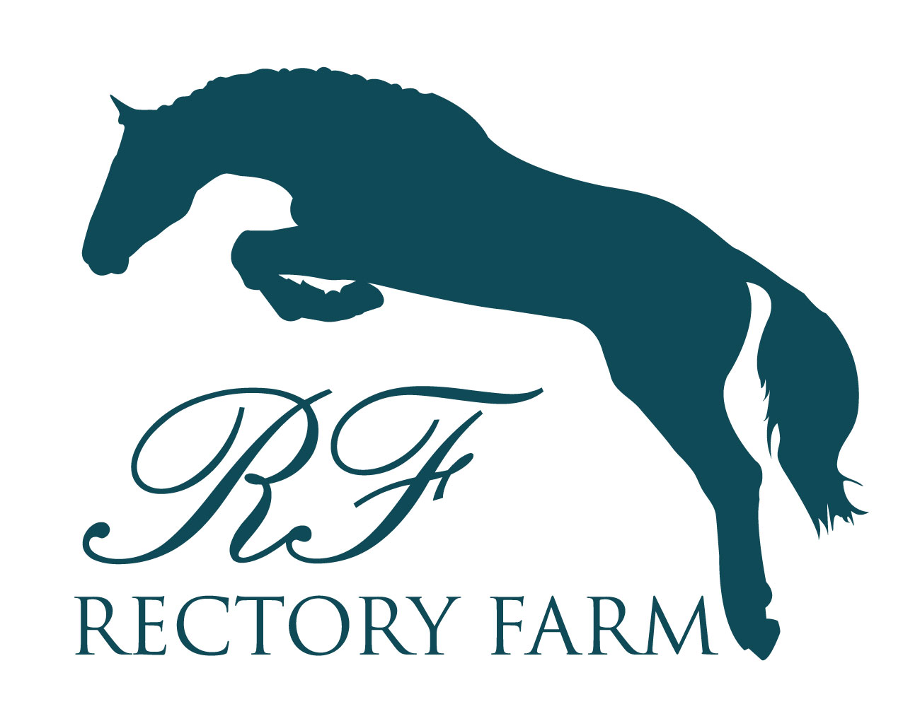
Land Rover Pony Club Regional Championships
26th – 28th August

Stabling & Camping Form

Stable Prices: £40 One Day, £30 Second Day, £10 Third Day

The stables are bedded on flax on grass, two bales are included and further bales can be purchased for £9 a bale on site. Please bring your own hay & hard feed

Camping is FREE

Send this form via email to arena@rectoryfarm.com or by post to 5 Rectory Farm Cottages, Duntisbourne Abbots, GL7 7JW
Pony Club Branch: |  | Name:
Contact Number: |  | Email:
Stabling Requirements
Name of Rider: | Days Staying: | Dates: | Cost:
Total:
Please Note: By applying for stabling & camping you are agreeing to the following rules: ALL droppings must be picked up, stables MUST be mucked out and tidy before you leave, any litter MUST be disposed of and NO horses/ponies can be left unattended when tied up. DCs of the PC branches concerned will be contacted if these rules are not followed.
Stables open at 2pm on Friday 25th August and close at 12pm on Tuesday 29th August.
On other nights stables are available from 4pm on the day of booking and must be vacated by 3pm the following day.

Pony Club Branch: |  |  | Name:
Contact Number: |  |  | Email:
Camping Requirements
Name: |  | Days Staying: |  | Dates: |  | Tent or Lorry?
Additional Notes:

There will be food and entertainment in the evening for everyone to enjoy, to purchase tickets please visit:
https://www.rectoryfarm.com/land-rover-pony-club-regional-championships/entertainment/

Please make cheques payable to Rectory Farm Arena Ltd
BACS Details (please include “STABLE surname” in the transfer information)
Sort Code: 30-80-95
Account: 40935468

